ISSTA Sonic Practice Now
Zoom settings for audio

There are two places to change settings: zoom.us in your browser and in the zoom app.

- Go to zoom.us and login to you account.
- Click settings on the left:
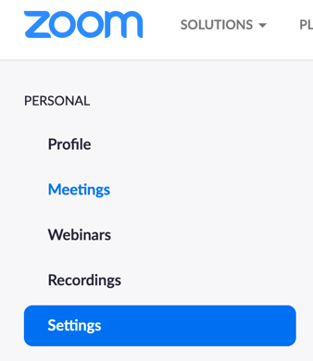

- Turn on the below
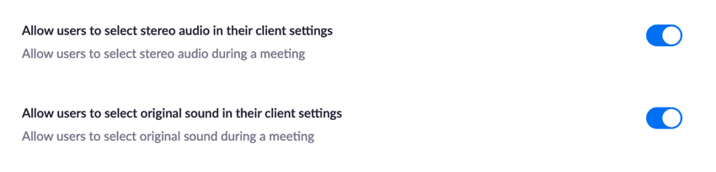
- Go to the zoom app and change to the following to enable best quality for music:
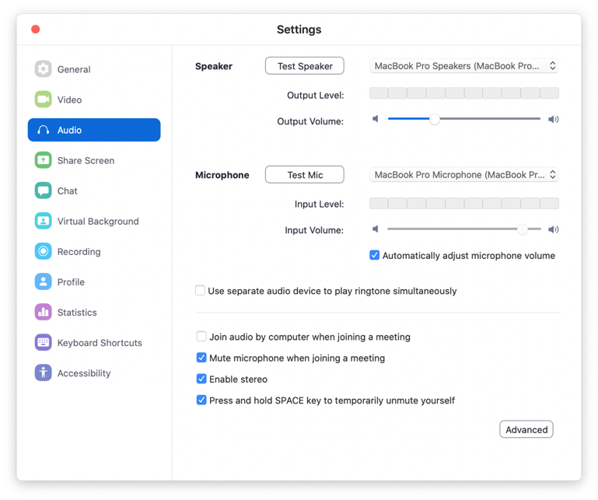
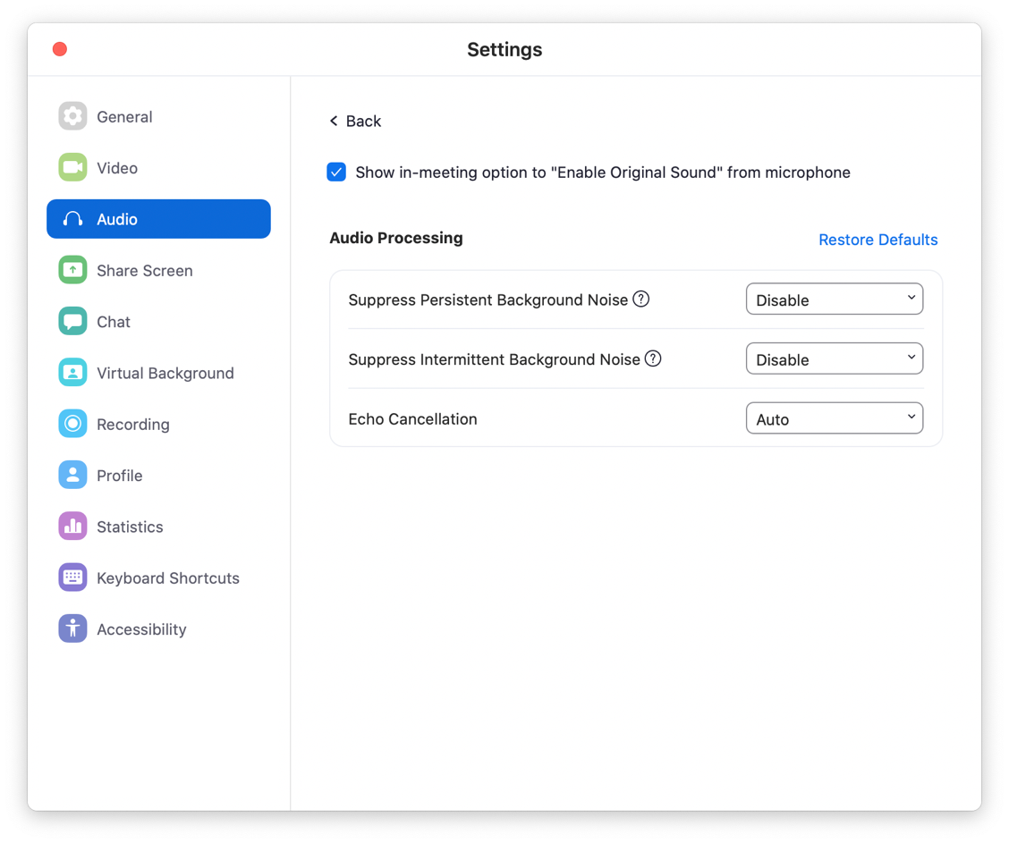
Please note that these settings are best for music, but not for conversation. You should change your settings back to the default when not streaming music.
- You will now see Turn on Original Sound as an option.
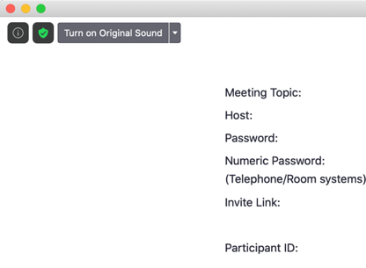

These are all the settings you need to change. Now to share/stream.
- Click share
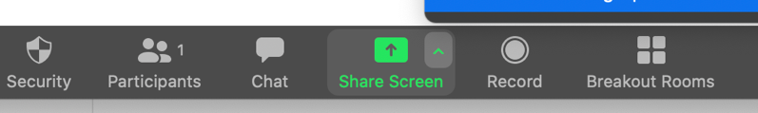
- Share:
  - Computer audio only
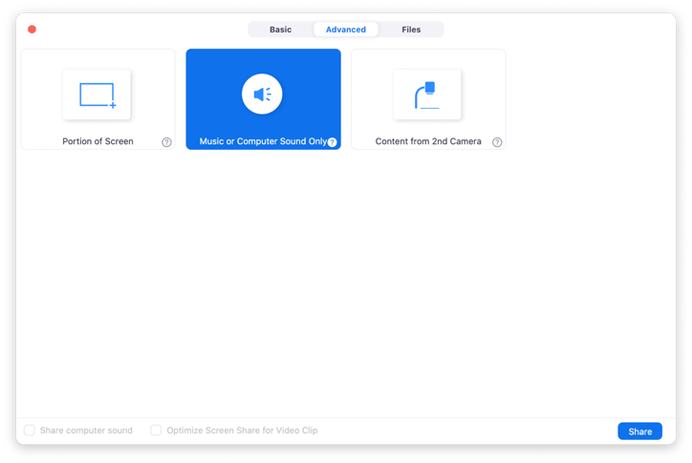
This will prompt a request to install ZoomAudioDevice. This allows you to share computer audio (rather than mic audio). This is similar to Loopback and Soundflower. You will then need to change the output settings of your DAW or whatever you are ‘sharing’ from to select ZoomAudioDevice as your output.
E.g. share from VLC: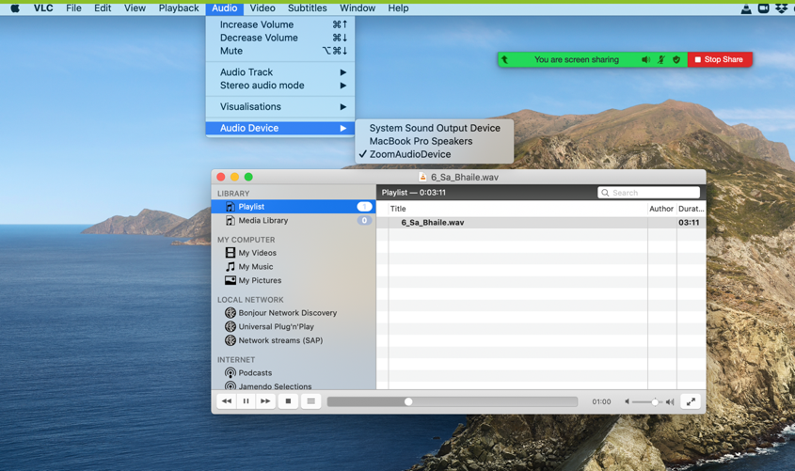
  - To share screen and computer audio:
